METALS

Structure:
Consists of a 3D lattice of positive metal cations surrounded by a sea of delocalised electrons

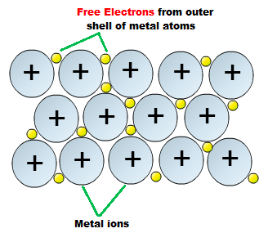

Nature of Bonding:
There is a strong force of electronstatic attraction between positive metal ions and the delocalised electrons. This is referred to as metallic bonding.

Property of metals | Explanation in terms of structure and bonding
High melting point | For a substance to melt you need to break the forces of attraction between particles. There are strong forces of electrostatic attraction between metal ions and delocalised electrons, therefore it requires a large amount of energy to break these bonds.
Electrical conductivity (solid state) | For a substance to conduct electricity there need to be mobile charge carriers. In a metal the delocalised electrons are able to act as mobile charge carriers, therefore metals conduct electricity in the solid state.
Electrical conductivity (liquid state) | When melted, both the delocalised electrons and the positive metal ions are able to act as mobile charge carriers, therefore metals conduct electricity in the liquid state.
Thermal conductivity | When metals are heated the mobile delocalised electrons gain kinetic energy. They move rapidly through the solid metal and transfer their energy to other particles.
Malleability & Ductility | The force of attraction between metal ions and delocalised electrons in non-directional. When a force is applied a row of ions is able to move into a new position without breaking metallic bonds.  